freETarget
Application Note: V6.0.1 Board Revision

INTRODUCTION
FreeETarget Version 6.0.1 requires a modification for reliable shot detection.
REQUIRED TOOLS
- Soldering iron and solder
- Small (1/2mm) drill
- Jumper wire
- Multimeter (resistance and voltage)
REVISION
Preparation
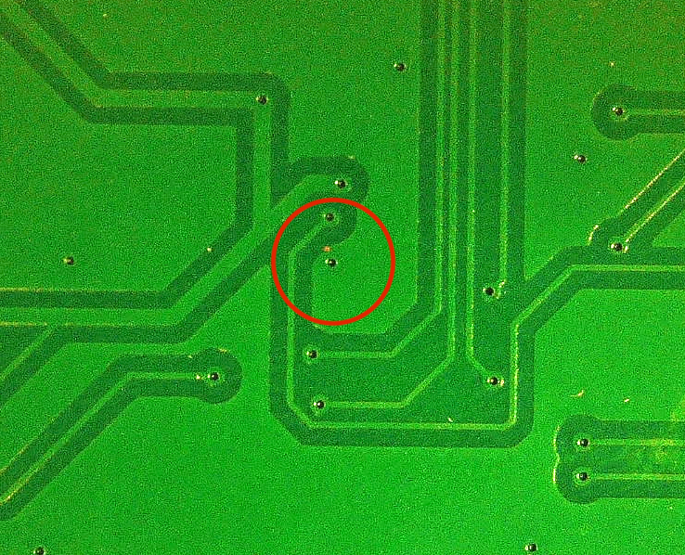 | 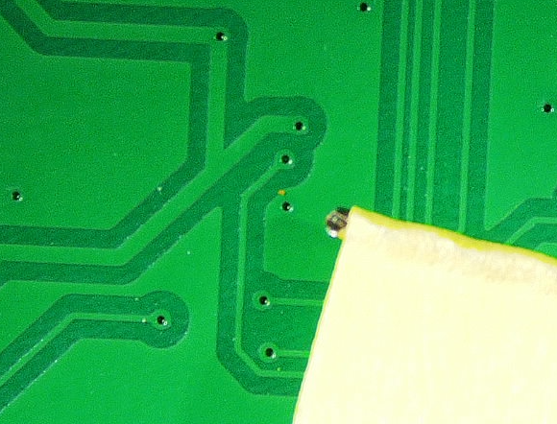
On the backside of the board  Locate the via for modification | Wrap a piece of tape at the end of the drill, exposing only a small portion of the drill tip.  This is done to prevent the drill from going too deep.
Remove the Ground Connection
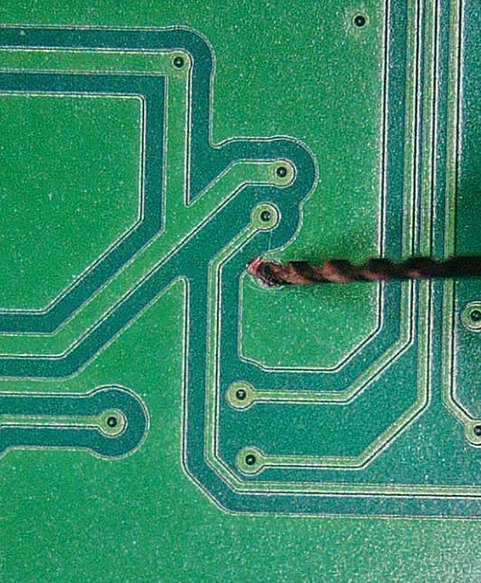 | 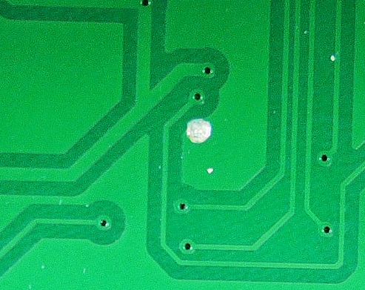
Drill the via. (Tape removed for example only)  DO NOT DRILL MORE THAN ½ OF THE BOARD THICKNESS | Successfully broken via  Note hole does not go all the way through
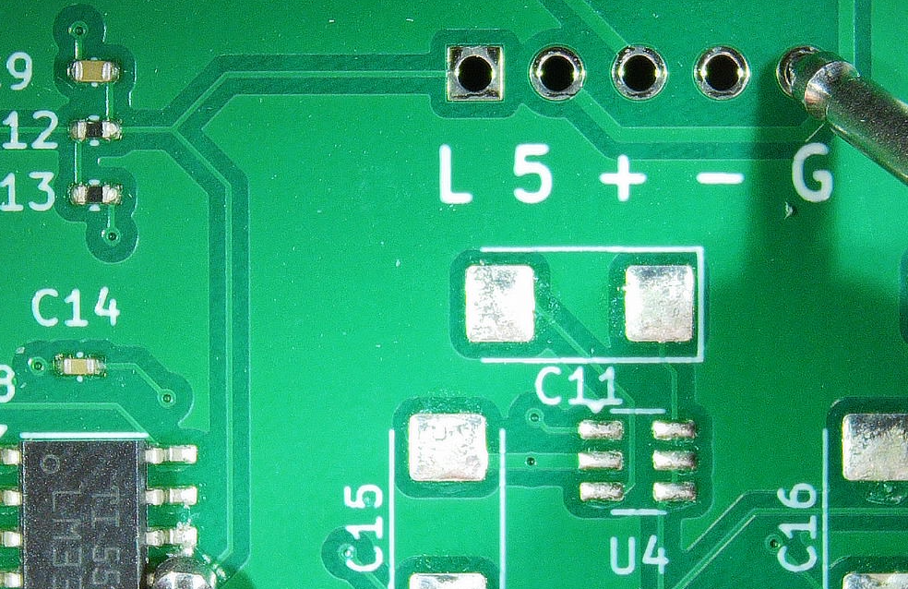
Measure the resistance between U8-12 and the Test Point (G).  Ensure that there is no connection (high resistance) between the points. | DO NOT CONTINUE TO THE NEXT STEP IF U8-12 IS CONNECTED TO GROUND  Repeat steps above taking care not to drill too deep
Insert the Jumper
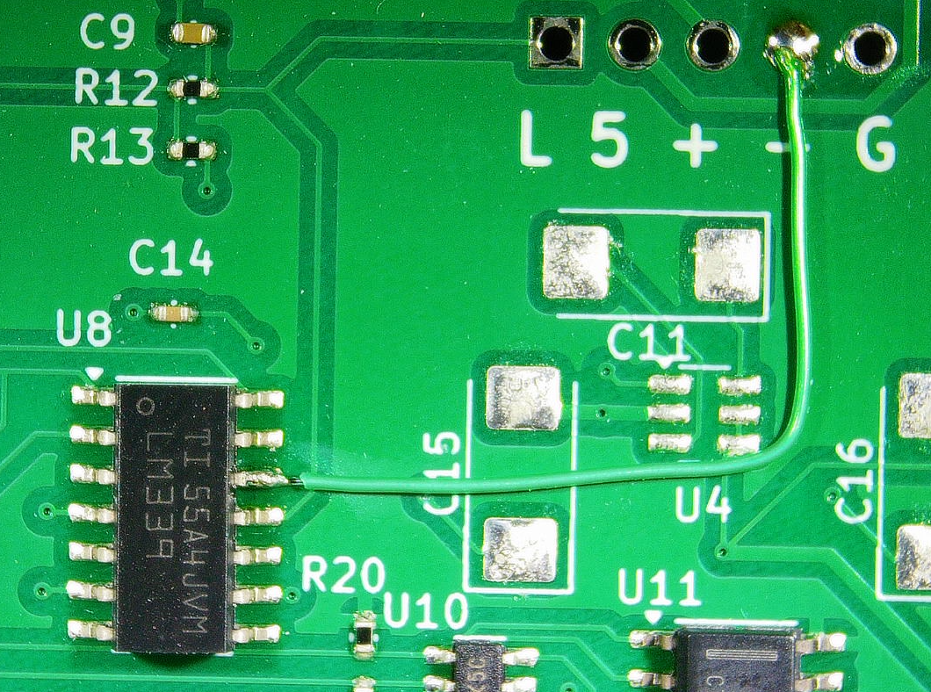
Place a jumper between U8-12 and the Test Point (-)
Testing
Apply power to the board  Measure the voltage between U8-12 and Test Point (G)  Verify that the voltage is nominally -5 Volts | Ensure that there are no shorts between any of the pins on U8 or the test points.

